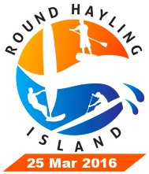
Round Hayling Island - Friday 25 March 2016
Safety Briefing to Sailors and Paddlers.
Issued 18/03/16

All essential information is available in Sailing Instructions, Instructions to Paddlers, and Course Chart. Should there be any discrepancies, then the Sailing Instructions and Instructions to Paddlers take precedence. All documents are available from event website here:
http://hayling.sailracer.org

There is a lot of useful detail in this briefing, so please take time to read it. The main points will also be covered at the Competitors and Participants Briefing on the day, 11am in the HISC main bar.

Disclaimer and Risk Statement.
Attention is drawn to the Risk Statement in Sailing and Paddling Instructions, which is repeated in your signed registration.

The decision to take part is yours and yours alone. You must be confident that you are capable of the event in the prevailing conditions. In the case of minors, the parent/guardian makes this decision.

This is important because there are special risks in undertaking a long course around Haying Island. It is not a simple sail or paddle from a beach and back. You will be out of sight of base for much of the course, there are many shallow areas, and landing is only safe in a number of places. The onus is on you to understand the course, the hazards, and the possible landings.

Safety Support.
We will provide safety support in the form of a fleet of patrol boats and the provision of GPS trackers. These trackers are a key part of our safety procedures and you must take one afloat with you, and return it to an official promptly after finishing or retiring. Failure to do either will prevent you being included in the results of the event. The same applies to the numbered vest which must be worn as your outermost layer with the number showing on your back.

The patrol boats are all manned by volunteers giving up their day to help you enjoy yours. They are all competent in their roles but no guarantee is given about their ability to help you. Any assistance given is at your own risk, and you accept this risk by participating.

The patrol boats will do their best to guide you in the correct direction and away from hazards. They will normally keep clear of you, so if you have any problem call them in by shouting or waving (both arms up and down is the international distress signal). We will also be tracking you by GPS and will aim to send a boat if you are stopped for long.

There are a number of places where you can land if you need to, and where you will be landed if recovered by our patrols. The SUP Company have very generously provided a mini bus to run you back to HISC. Our shore teams will watch your equipment while you return with your car.
The Courses.
See the Course Chart and Sailing/Paddling Instructions for details of courses.

Starting:
Bronze, Silver, and Gold courses, windsurfers SUPs and OCs, and the SUP Fun Course, will all start on a starting line between the flag pole on the Race Box at HISC, and the navigation mark NW Winner. The line lies approximately west-east and the starting direction is north. OCs start first, then windsurfers, then SUPs. See the Sailing and Paddling Instructions for the starting signals.

You must be to the south of the line at the starting time to start correctly. If you are not, then you must move south of the line before proceeding on the course.

For windsurfers, gate start using a patrol boat may be used. In this case, at the starting time, a patrol boat towing an inflatable buoy will leave the beach at the western end of the line and will proceed along the line heading east. You must pass behind the patrol boat and buoy. If you accidentally pass in front, then you must return to the south of the line before proceeding on the course.

Remember that GPS tracking will record your movements!

Bronze Course:
From HISC to Northney and back. You decide at Gate1 at Northney whether to go on or turn back. Most of the course is in sight of HISC, and navigation is easy. The finish is on foot on the beach at HISC, identified by a flag.

Length approximately 9 miles. There is a landing point at Northney if you want to retire there, and our team will watch your equipment while you return to HISC in the SUP Co bus.

For SUPs, if conditions are very difficult in Langstone Harbour, we may close Gate1 by flying a red flag. You must follow the Bronze Course by returning to HISC.

Silver Course:
From HISC, through Gate1 at Northney and on to finish at Gate2 at the Ferry Boat Inn (Langstone Harbour Entrance). You decide at Gate2 whether to record a Silver Finish there or press on for a Gold Finish (you cannot record both). The finish is on foot on the beach near Ferry Boat Inn, identified by a flag.

Length approximately 9 miles. We'll have a team based there who will watch your equipment while you return to HISC in the SUP Co bus.

VERY IMPORTANT. We close this gate if conditions are too difficult on the sea front, and to prevent the tail of the fleet taking too long for safety on the Gold Course. If a red flag is flown then the gate is closed and you must finish here.

Gold Course:
Complete circumnavigation back to HISC. The sailors who choose to carry on at Gate2 then pass through Gate3 and Gate 4 off the beach, and turn in to Chichester Harbour to finish at HISC. The finish is on the water, by crossing the same line as the start, in a northerly direction. To record a Gold Finish, you must hand in your trackers and bibs as soon as you land. Length approximately 14 miles.

VERY IMPORTANT. We intend to shorten course at an appropriate time, to avoid a long struggle with the ebb in Chichester Harbour Entrance. See ‘Shortening the Course’, below.

We'll have teams based at all three sea front gates, so if you retire or finish they will watch your equipment while you return to HISC in the SUP Co bus.

SUP only Fun Course:
A shorter 4 mile course, all in sight of HISC, for less confident paddlers and smaller boards. The start will be with the main SUP start. The course will pass around a clearly identified mark approximately 2 miles north of the start and the finish will be back on the HISC beach, the same as for the Bronze Course.

SUP NOTE: Only boards 12'6" and longer may tackle the Silver and Gold Courses. Shorter boards must choose either Bronze or Fun Courses.

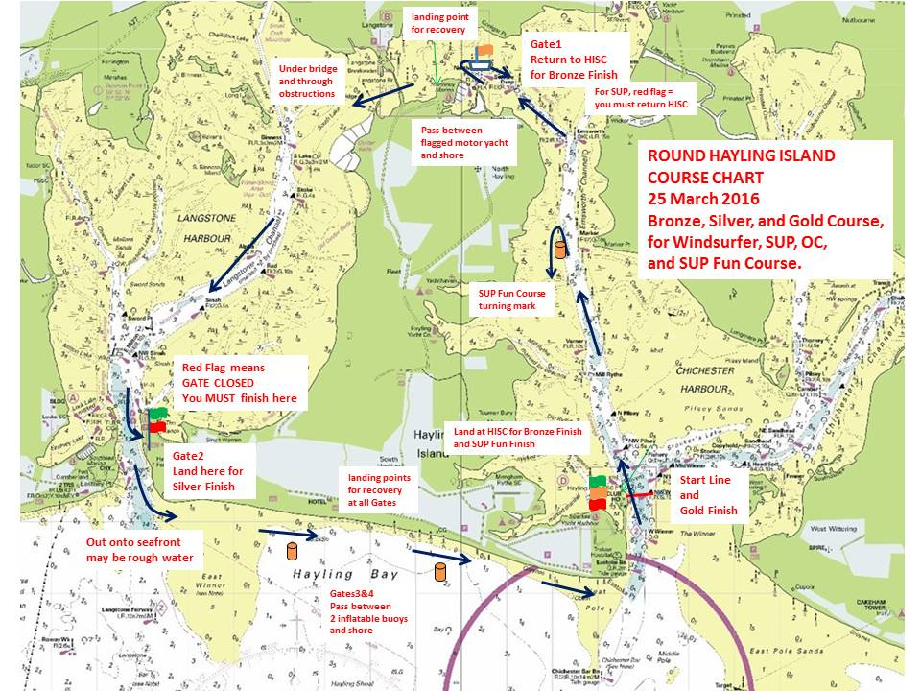

GPS trackers and bibs to be returned to the Event Office as soon as you get back to HISC. When you will also receive a SUP Company Goody Bag
Specific hazards of the route.

Collision avoidance:
The water may get quite crowded with different craft taking different routes and at different speeds. Remember Collision Regulations, which apply to all water craft. Keep clear of any vessel with limited manoeuvrability, and keep clear of any vessel that you are overtaking.

Mud flats on all harbour legs:
If you run aground and get stuck on mudflats then stay with your board. Make every effort to re-float, but if you cannot then stand and wave to attract attention from our patrol boats. People have become trapped in the mud when trying to walk which can be very dangerous.

Hayling Bridge and nearby obstructions:
The clearance under the bridge is only about 1.7m at high water. A channel is marked and this is the recommended passage. There could be obstructions anywhere outside the channel. After passing under the road bridge remains of the dismantled rail bridge must be passed. Again a channel is marked.

Direction to Langstone Harbour entrance:
The entrance cannot be seen from the north end of Langstone Harbour. The direction is approximately SW. Depending on your exact route, the entrance might only be visible on the final approach. Harbour Master buildings and jetty on the Hayling side are quite prominent.

Large ships in Langstone Harbour, unable to manoeuvre:
A specific Harbour Master requirement, you must keep at least 500m clear of ships in Langstone Harbour. Our patrol boats may direct you. If you disregard instructions or impede progress of a ship, you will be excluded from results.

Rough water and strong currents at Langstone Harbour entrance:
If you decide to continue past the Silver Finish, assuming that Gate2 is still 'open', then you will be heading into fast flowing and potentially rough water. Walking your board around the corner onto the sea front may be an option.

Shallow breaking seas over sand banks near entrances:
Both harbour entrances have long sand spits beside them pointing out to sea. They will become shallow as the afternoon progresses and may be rough. Both dry for a mile out at low water. Walking across or along the beaches may be an option.

Rough water and strong currents at Chichester Harbour entrance:
As you turn into Chichester Harbour expect a strong tidal flow against you and rough water. Again walking on the shore may be an option. (Note that we have suspended the sailing rule which disallows walking with your craft, it is permitted in this event.)

Shortening the Course.
The course may be shortened at an appropriate time and place to reduce risks.

High Water is at 12:44. Within 2 hours the ebb will be running strongly at the harbour entrances. This will cause rough water and will make the final approach to the finish at HISC difficult or impossible.

Therefore, at a time to be decided as conditions develop, we intend to close Gate2 at the Silver Finish at Langstone Harbour Entrance. Any participants who have not already passed this gate can be expected to take a very long time negotiating the sea front, and we would like everyone landed by around 16:00. Our patrol boats will have difficulty with low water after this time.

Should conditions in Langstone Harbour be difficult, we may shorten SUP or OC courses at Gate1 at Northney. This will be signalled by a red flag at the gate. In this case you must return to HISC to record a Bronze finish.

It may be that we will find it necessary to shorten the course at other locations to prevent participants spending too long on the water. This will be done by a patrol boat with flag giving clear indications, including sound signals. Competitors finished in this way will be awarded a Gold Finish.

Whichever course you follow, and wherever you finish, we hope you have a fun and safe day!
Thank you for paying attention.

